Engels lezen oefenexamens.

1. After having waited for more than 2 hours at customer service
2. 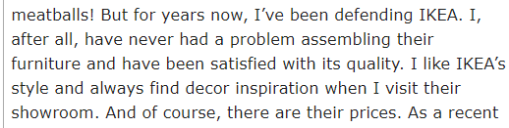She thinks the assembly of their furniture is doable and she feels roaming their showroom sparks her creativity

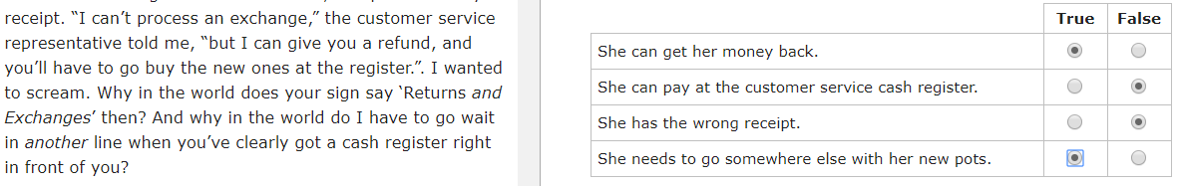

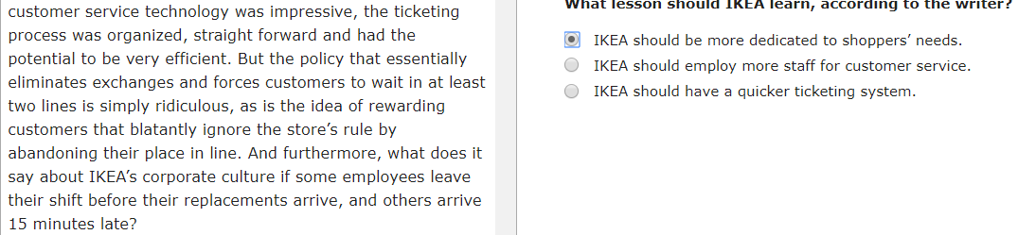

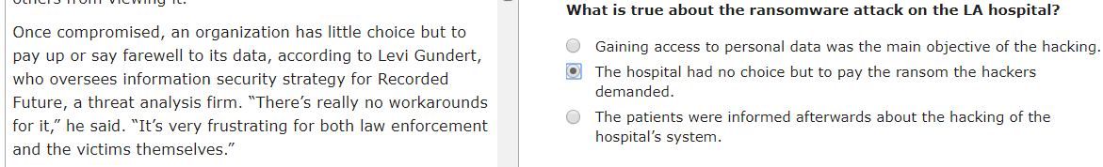

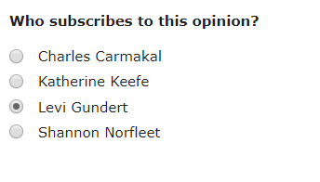

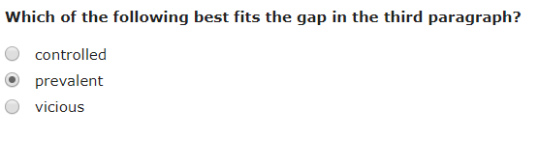

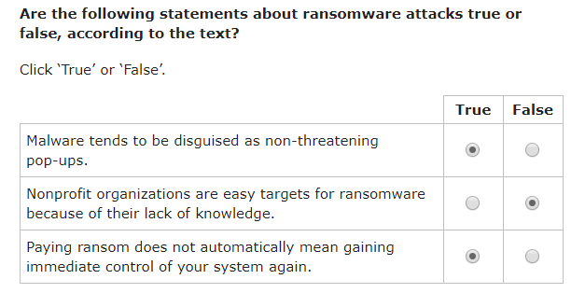

9. ironic

10. 